1. ***How to compare two JSON have the same properties without order?***
   1. ***var obj1 = { name: "Person 1", age:5 };***
   2. ***var obj2 = { age:5, name: "Person 1" };***

var flag=true;

for(let key in obj1)

{

if(obj1[key] == obj2[key])

{

continue;

}

else

{

flag=false;

break;

}

}

console.log(flag);

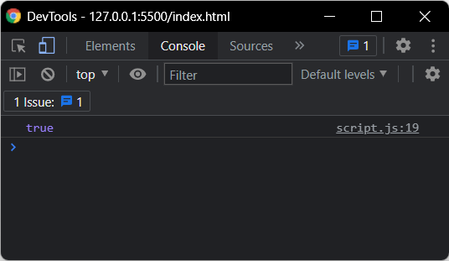

1. ***Use the rest countries API url ->*** [***https://restcountries.eu/rest/v2/all***](https://restcountries.eu/rest/v2/all) ***and display all the country flags in console***

***var xhr = new XMLHttpRequest();***

***xhr.onload = function(){***

***if (xhr.status >= 200 && xhr.status <= 400){***

***var temp = JSON.parse(xhr.responseText);***

***temp.forEach(element => {***

***console.log(element["flag"])***

***});***

***console.log();***

***}else{***

***console.log(xhr.responseText);***

***}***

***};***

***xhr.open("GET","https://restcountries.eu/rest/v2/all")***

***xhr.send()***

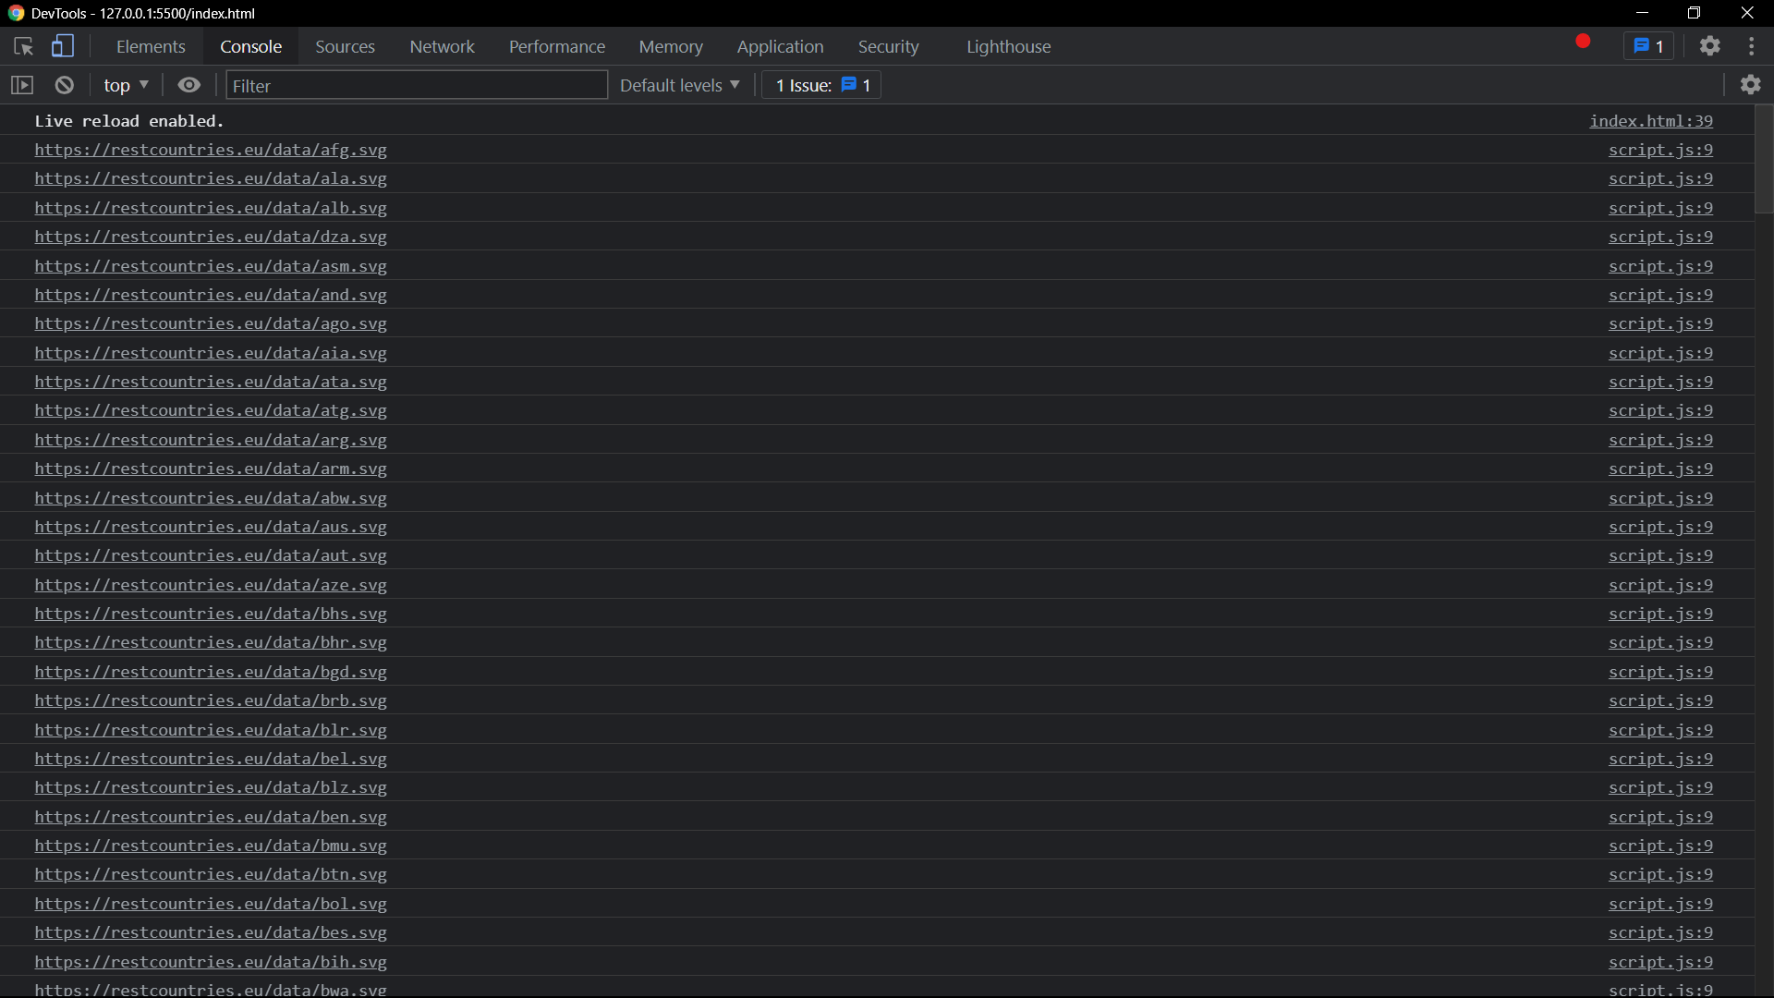

1. ***Use the same rest countries and print all countries name, region, sub region and population***

***var xhr = new XMLHttpRequest();***

***xhr.onload = function(){***

***if (xhr.status >= 200 && xhr.status <= 400){***

***var temp = JSON.parse(xhr.responseText);***

***const keys = ["name","region","subregion","population"]***

***temp.forEach(element => {***

***for (let key of keys) {***

***console.log(key + " : "+ element[key]);***

***}***

***});***

***}else{***

***console.log(xhr.responseText);***

***}***

***};***

***xhr.open("GET","https://restcountries.eu/rest/v2/all")***

***xhr.send()***

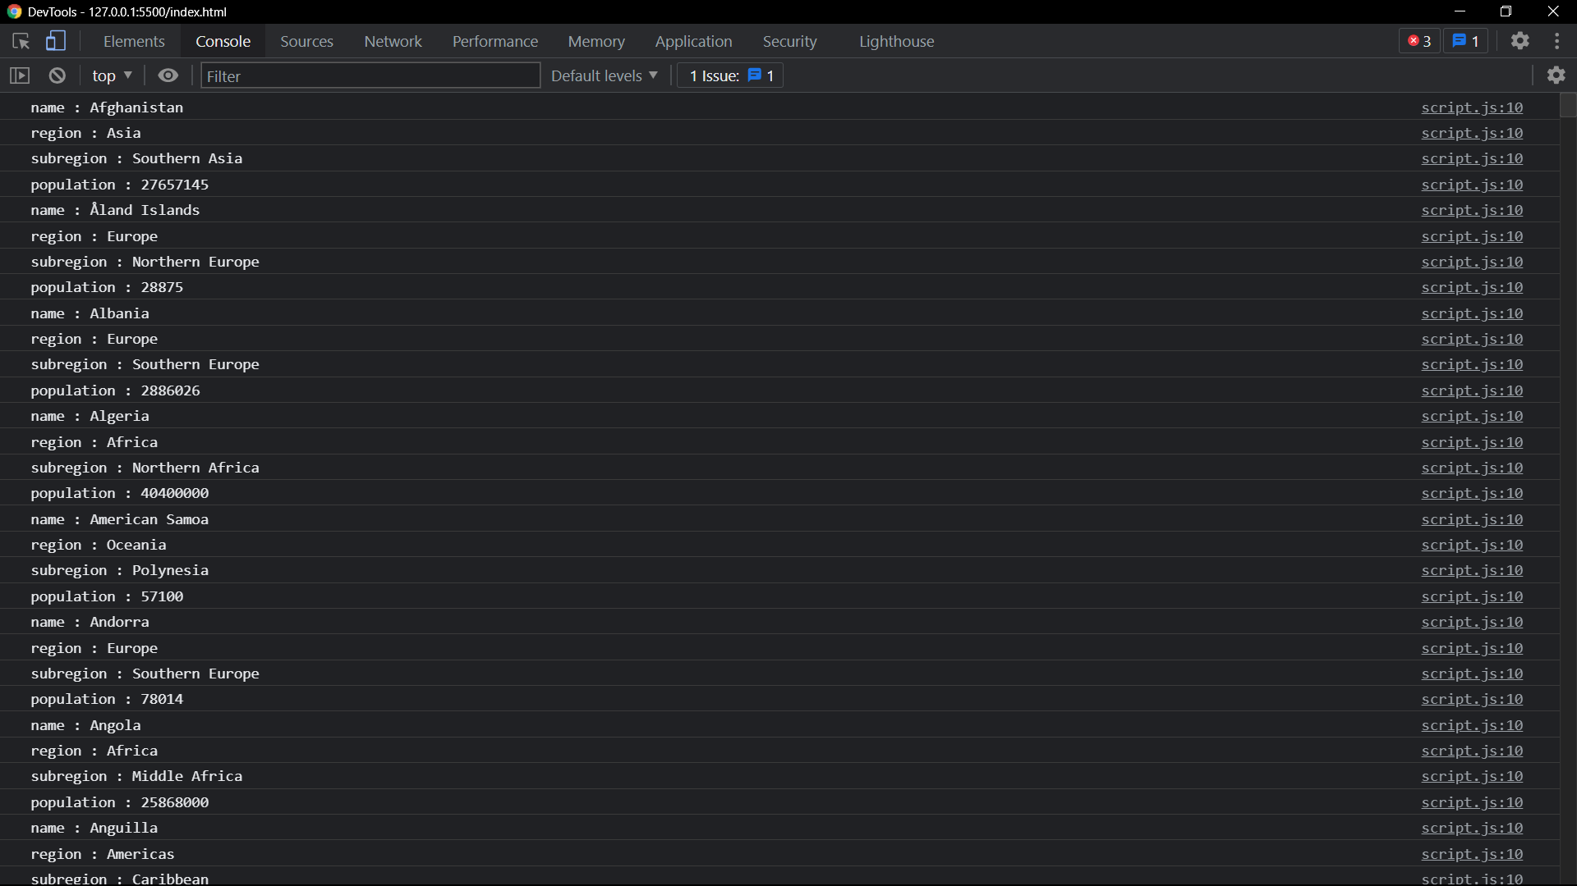

1. [***https://medium.com/@reach2arunprakash/www-guvi-io-zen-d395deec1373***](https://medium.com/@reach2arunprakash/www-guvi-io-zen-d395deec1373)